**INTRODUCTION**

Designed to provide insights into our sales performance our sales dashboard offers a user-friendly interface that transforms complex sales data into easily digestible visualizations, enabling decision-makers with the information needed to optimize strategies, track KPIs, and make data-driven decisions. With interactive features, this dashboard offers an all-encompassing view of sales trends, customer behaviors, and revenue analysis, driving growth and success for our organization.

This executive summary will provide a high-level overview of the key findings, achievements, and recommendations resulting from this project. In the following sections, we will outline the project’s methodology and important discoveries, and provide some suggestions based on our findings.

**CONTENT**

**Data Overview**

This Data contains 17 columns and 17423 rows. The minimum, maximum, average, and total revenue generated by a customer in this data set is three, 5398, 1249.282, and 21764991 respectively.

**Methodology and Analysis**

1. Data Cleaning: Used Microsoft Excel for the entire cleaning process. Used functions like right() and Len() to remove special characters from an entire column, changed the data from number columns stored as strings to their correct data types, used sort and filter to remove unwanted characters, changed the date column to its correct data type and used auto-fill to input the newly cleaned data.

2. Data Analysis: Obtained aggregated measures such as the total number of rows, total revenue, minimum revenue, maximum revenue, and the average revenue using functions in Microsoft Excel such as MAX(), MIN(), AVG(), SUM() and COUNT(). Created new columns for the customer name by joining the 'first name' and 'last name' columns, weekday, month, and year using the CONCATENATE(), WEEKDAY(), MONTH(), YEAR(), and TEXT() functions. Created a new column representing the age band of the customers using the VLOOKUP () function.

3. Data Visualization: Created a dashboard illustrating the information obtained from our analysis. It contains a pie chart and a donut chart used to compare the revenue generated by customers based on their gender and age band respectively,

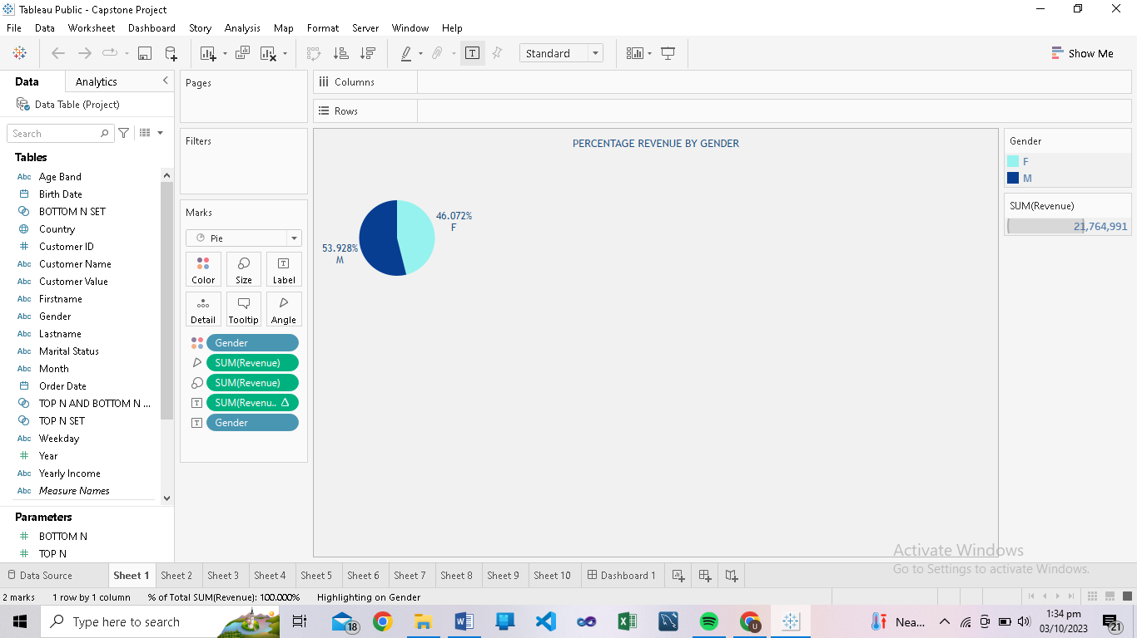 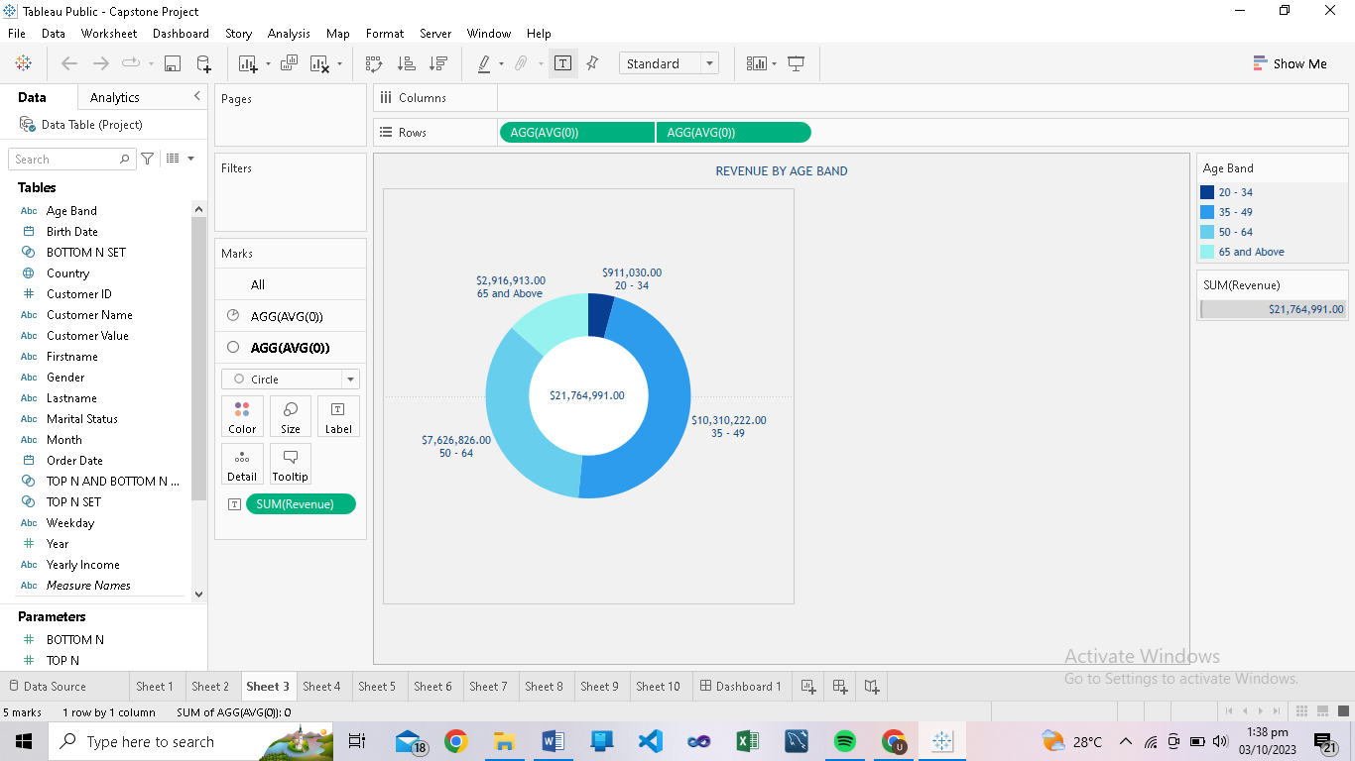

Text boxes to display the country and the year with the highest revenue,

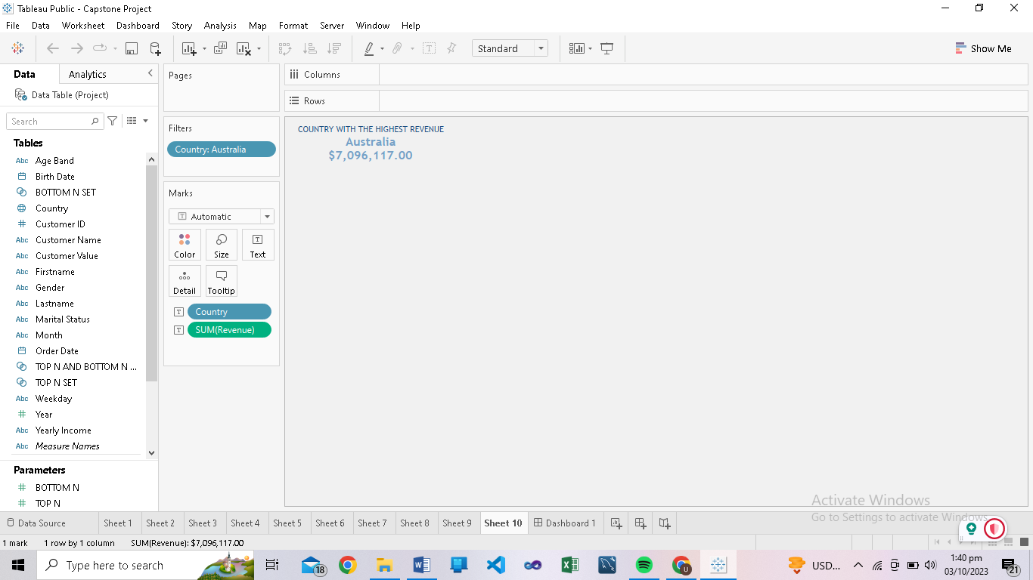 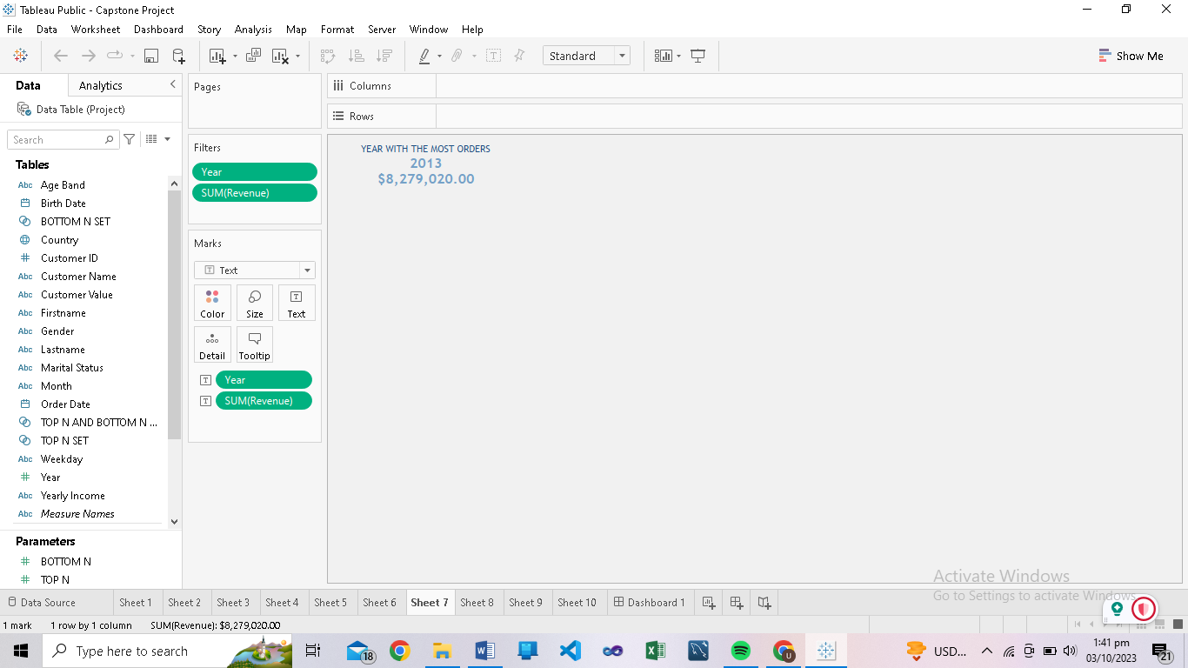

In addition, vertical and horizontal bar charts to compare revenue generated by customers based on their customer value and marital status.

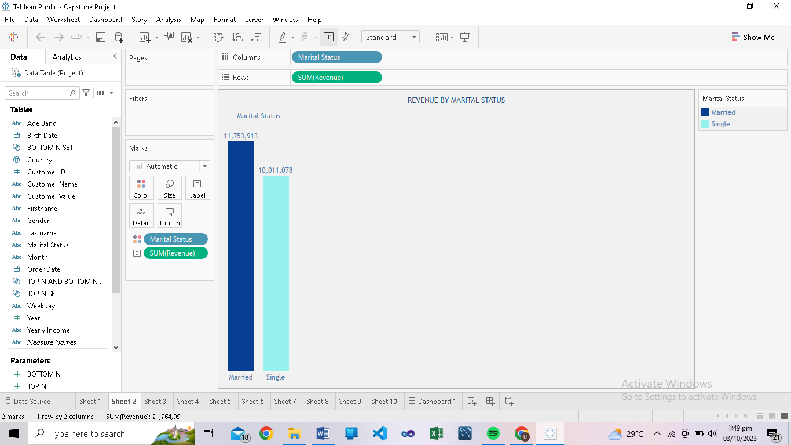 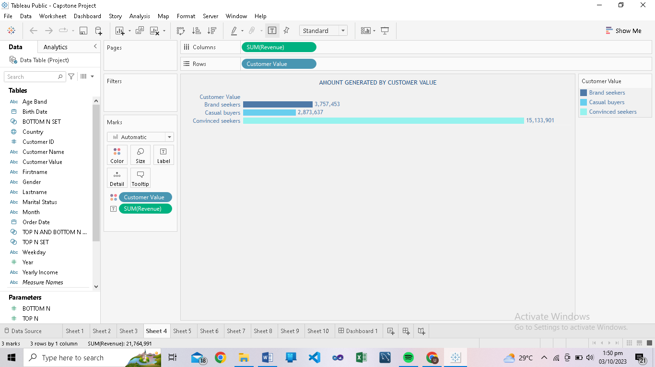

It also contains a top n and bottom n chart to display the top 5 customers with the most and least revenue,

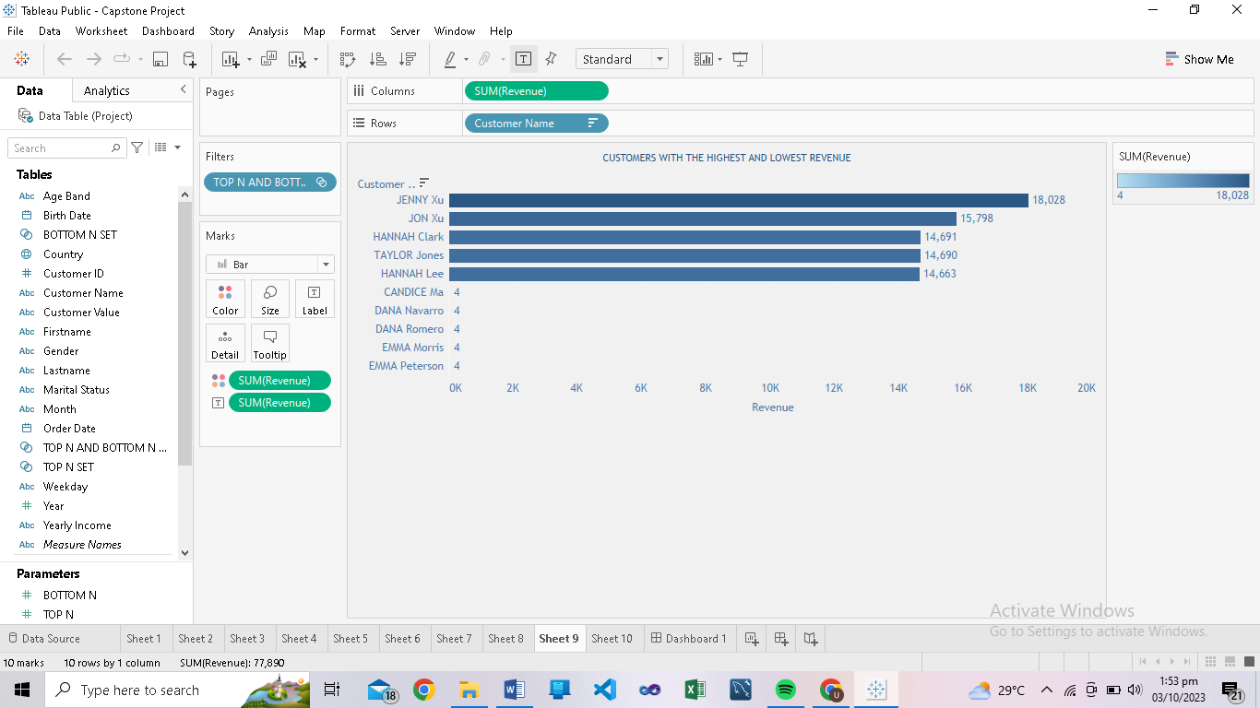

A stacked bar chart to compare the revenue generated by each weekday for each quarter in a year and a table to display the quarter in each year with the highest revenue.

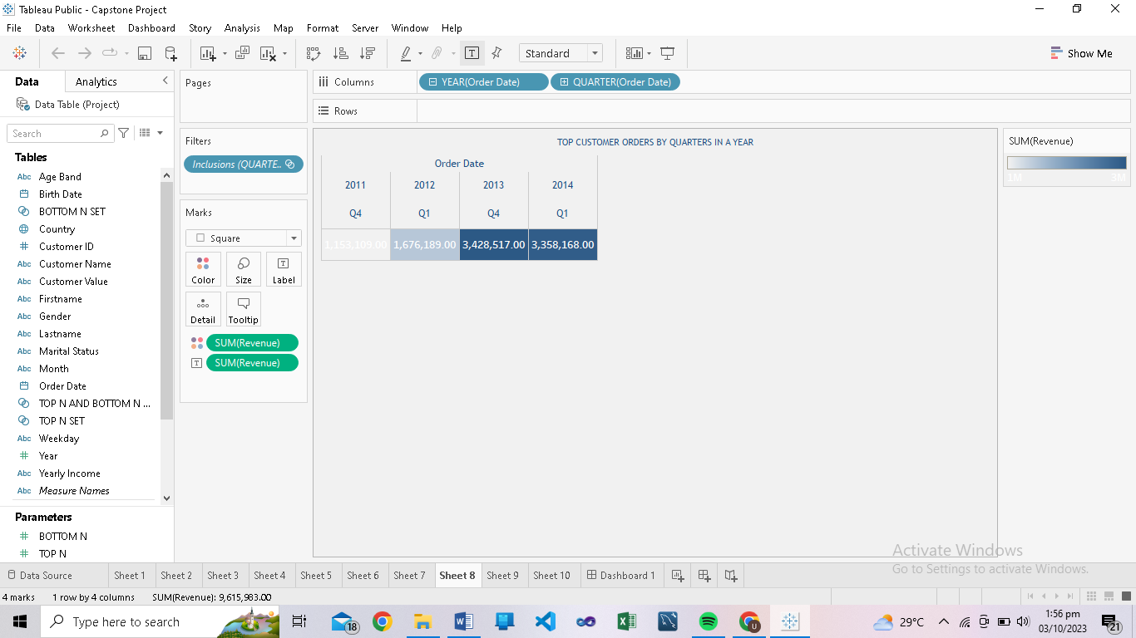

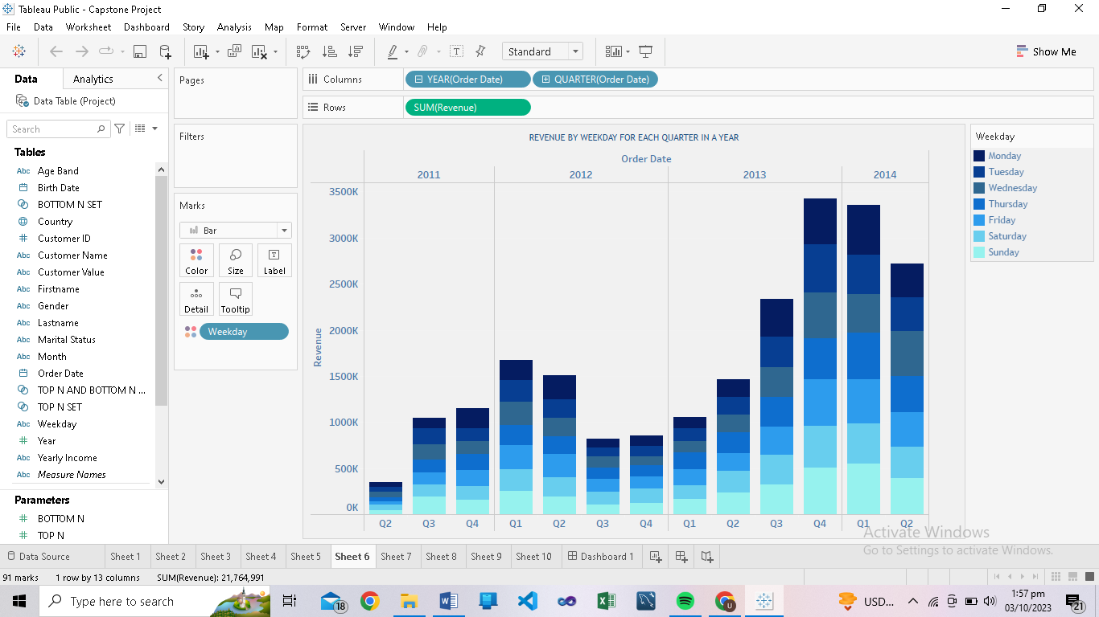

Lastly, it contains an area chart to show the revenue generated by each weekday in each year.

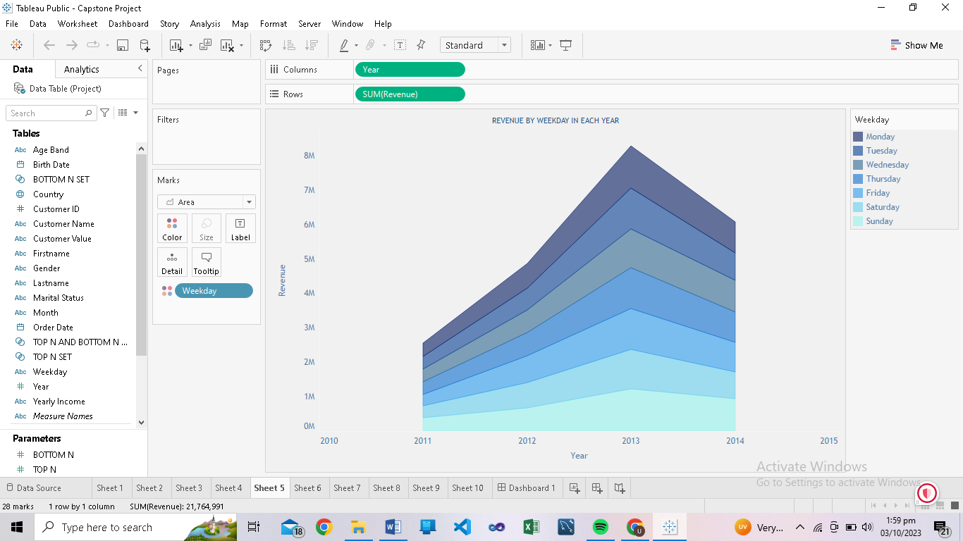

**Future-Work/Improvement Plans**

1. User Feedback: We need to collect user feedback, as it will encourage continuous testing and validation of our dashboard. Solicitation of feedback from the dashboard users will help to identify pain points and areas of improvement.

2. Additional Data sources: Integrating more data sources will provide a more detailed view of sales and related metrics, and an expansion in the size of the data will lead to improved insights and enable better decision-making.

3. Enhanced Interactivity: Adding more interactive elements like drill-down options, additional filters, and so on will help to improve the overall user experience.

4. Predictive Analytics: There is the possibility of incorporating predictive analytics into the dashboard. Using Predictive Analytic models can help forecast future sales that provide data-driven insights for improved decision-making, cost reduction, and risk management and help in optimizing marketing campaigns.

**Conclusion**

This data analytics project focused on obtaining insights to improve company sales by utilizing a detailed dataset of customer behaviors and purchase histories. These insights have enabled us to make the following key business suggestions:

1. Implement targeted digital marketing campaigns to increase sales within the 20-34 age demographic. Could include but not be limited to social media advertising, influencer collaboration, personalized content, etc.

2. Create a Customer Loyalty Program for Casual Buyers to incentivize them to make more frequent and larger purchases, which could be exclusive discounts, special access, point-based rewards, etc.

3. Implement an inclusive sales growth strategy to drive growth and total revenue for the second and third quarters of each year.

4. Create a Sales recovery and growth strategy to address the decline in sales from 2013 to 2014.

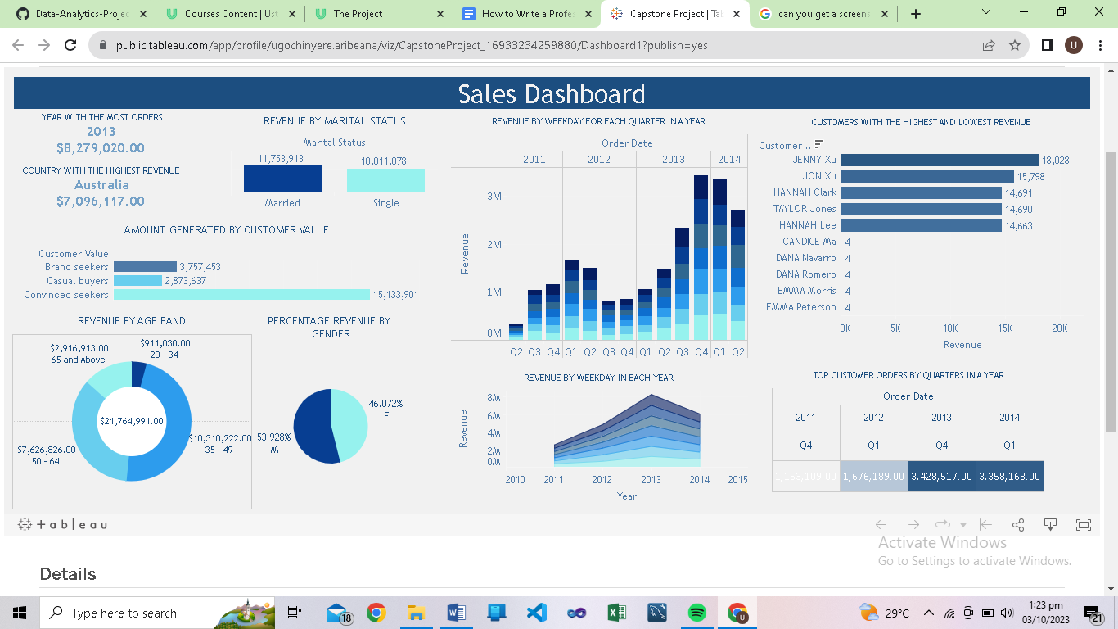

The above image displays the Sales Dashboard

For access: <https://public.tableau.com/app/profile/ugochinyere.aribeana/viz/CapstoneProject_16933234259880/Dashboard1>